**Design**

* *Analyse UML(use case,Sequence/Activity)*

In terms of our design we decided to structure it to be as simple to use as possible. This is as the main focus of the app(the AR implementation)has potential to be quite fiddly with some users and so we would like the rest of their experience to be easily understood and laid out.

We have laid out the structure of our app using UML diagrams. One of which is the sequence diagram.

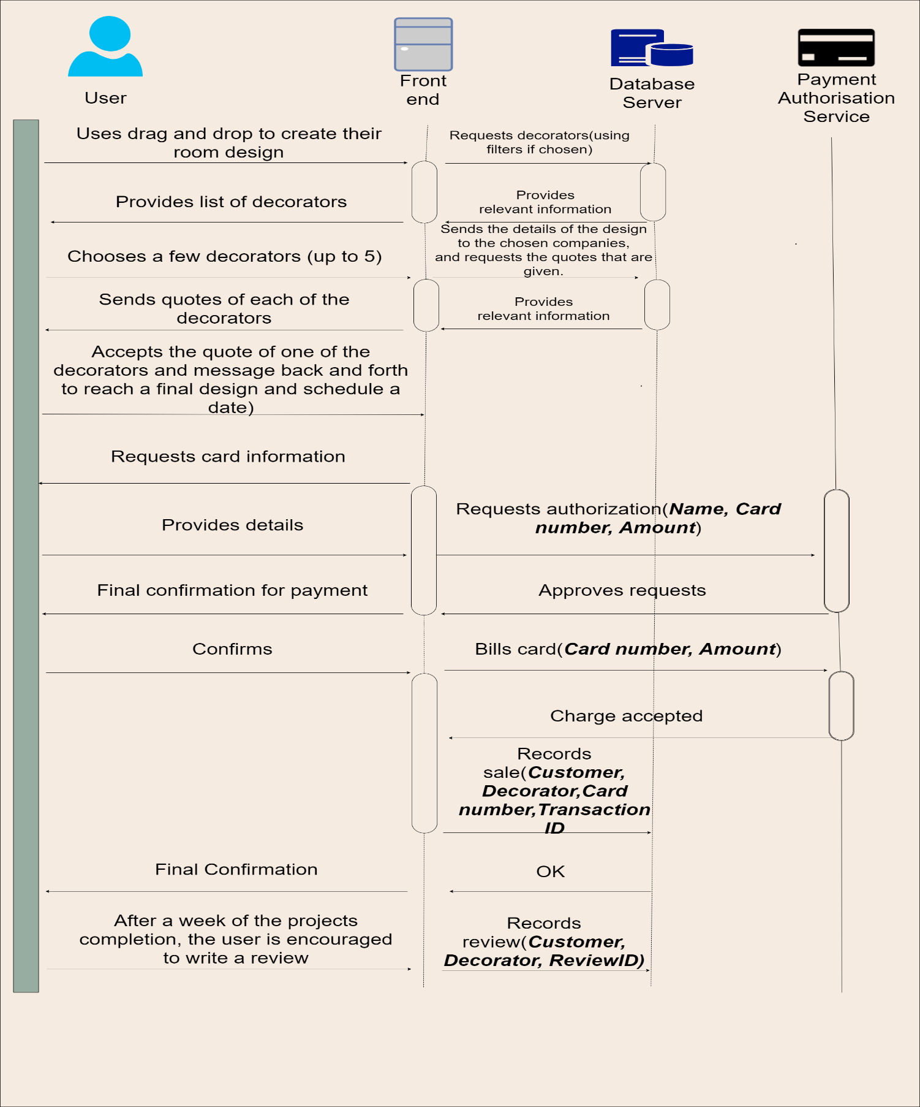We have laid out the structure of our app using UML diagrams. One of which is the sequence diagram. This diagram displays the normal scenario that would take place in the case of a customer that wants to make a purchase.

In the case of the activity diagram, scenarios that may occur have been shown and been assigned follow up actions. An instance where this occurs for example would be if the user had entered incorrect bank detail, in which case they would be sent back to another node in the sequence and begin to make another attempt.

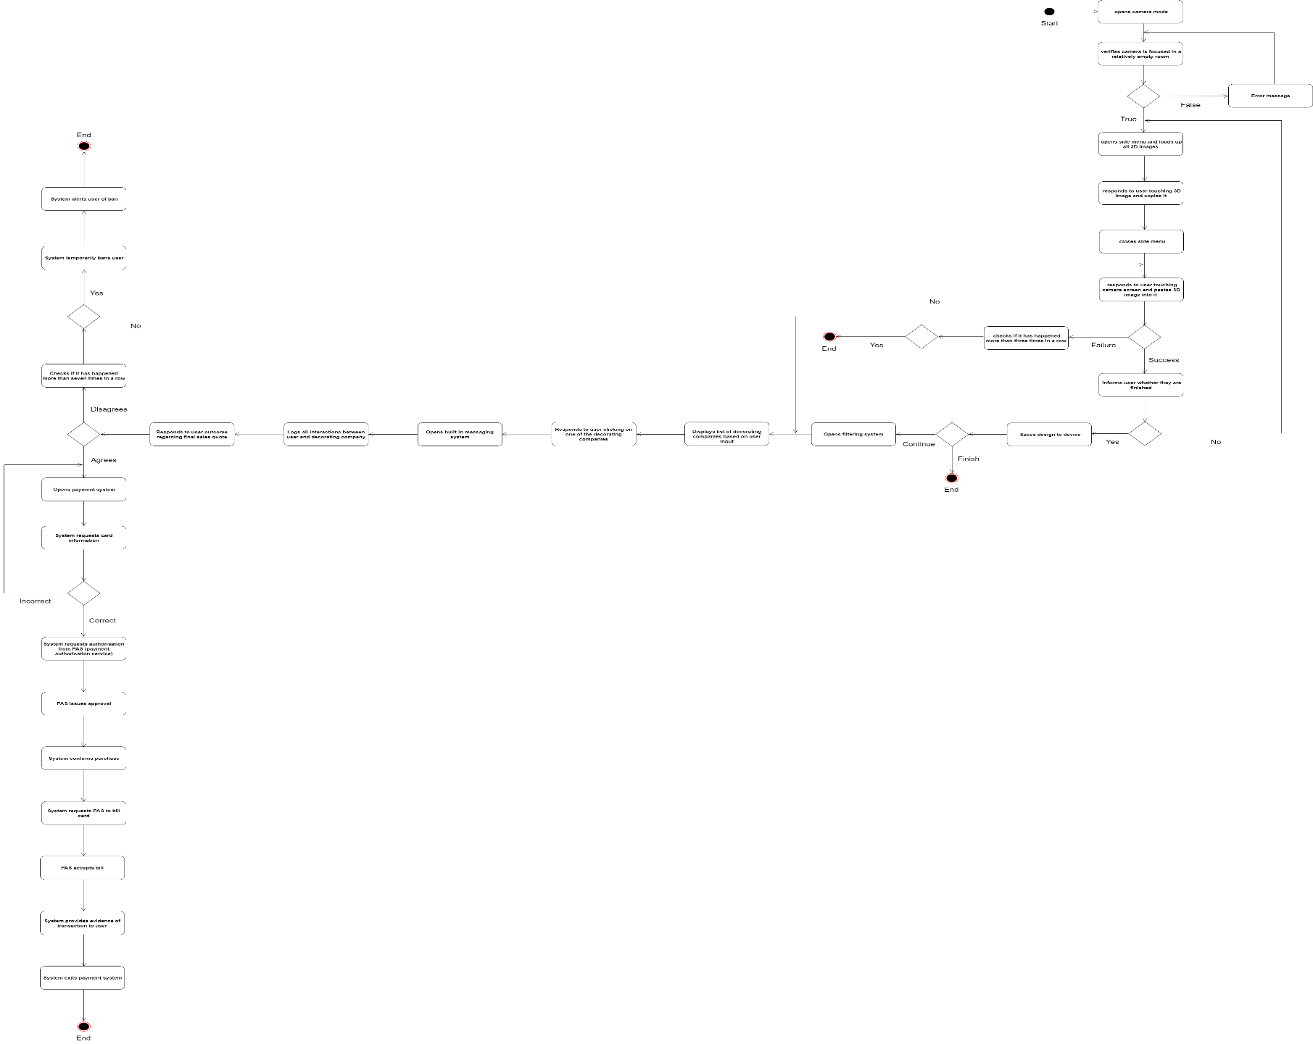

However, the customer is not the only user of the app. One of the main features that separates the app from its competitors is the inclusion of another stakeholder, the decorators. These users don’t have to make designs as the customer does, however they have the option to, should they choose to include them in their own portfolios (which the users would view before selecting their decorator).The profile for the decorator would be more elaborate than that of the customer as it is used to sell themselves .As a result of this it would include other features such as the reviews that they have received thus far through the app, a portfolio of their previous projects, as well as their qualifications. All of which are vital for them to persuade the customer to select them, which is especially important for the decorators that are freelancing as they are a stakeholder that can potentially make a viable revenue stream that they may not find through the app.

**Prototyping**

For our conceptual prototype, we made a preliminary layout/wireframe of our app. *MarvelApp* is a tool that we used in order to create the low fidelity prototype. We created the stages that the user would take in their journey through the app.

To begin with the user is greeted with a create account screen, where they can input their details. We learnt from a few of the potential users that we questioned that a simple registration is preferable and one that doesn’t involve storing their bank details, this is as, understandably, some users may be sceptical about how well their information would be kept without viewing the app first. We also learnt from some of the users that it may be tedious to create a new account and password for a new app, therefore we have adapted to this by adding the option to sign in via Facebook or Google, this is something that is very popular, however something that cannot be implemented exclusively, as it would create a great inconvenience for many customers who do not have those accounts and could drive customers away before they even view the app, as was the case with Spotify for instance, who by

The next important interaction would be their profile which initially would only contain the user’s contact information. However, through the use of the app the user would have created snapshot designs that they would want to save,

<https://news.ycombinator.com/item?id=3038815>